

Fulton County
Medical Examiner
2023 Annual Report



Karleshia Bentley, Executive Assistant & Hailey Evans, Forensic Technician
On behalf of
Karen E. Sullivan, MD, Chief Medical Examiner

Prepared by:

TABLE OF CONTENTS

Preface 3
Section I. Introduction 4
Section II. All Reported Cases 7
Section III. Manner of Death: Homicide 8
Section IV. Manner of Death: Suicide 9
Section V. Manner of Death: Non-Vehicular Accident 10
Section VI. Manner of Death: Motor Vehicle Accident 12
Section VII. Manner of Death: Undetermined 13
Section VIII. Manner of Death: Natural 14
Section IX. Graphic Depictions: Caseload and Case Type 16
Section X. Special Topics 17
Deaths among Children 18
Deaths among the Elderly 20
Drugs Identified in 2023 Death Investigations 24
Deaths among the Homeless 25
Comparisons with the Past 27
Comments 28

Preface

The data contained within this report reflect the activities associated with investigations of death occurring in Fulton County, GA in the year 2023. The delay in the publication of this report is due in part to the fact that some death cases can take many months to finalize because of extensive testing or the need for investigative information that takes time to obtain. The Report itself takes time to prepare and must be done while we carry out our usual activities and death investigations, which also takes the time of our staff.

I would like to thank the employees of the Fulton County Medical Examiner’s Office for their dedication, excellence, and quality death investigations conducted for the citizens of Fulton County. Without their commitment to deliver a high-level of service, quality investigation of deaths in Fulton County would not occur, and neither would professional communication with the many agencies and members of the public who are impacted when a death occurs. Our staff care for and maintain an accredited facility in which death investigations may be professionally conducted with respect to the dead and at which members of the public, legal, and law enforcement communities can effectively conduct their business.

It is hoped that the information in this report may be useful to public health, public safety, and other policy and program planners who strive to improve the safety and quality of life.

Karen E. Sullivan, MD
Chief Medical Examiner

SECTION I. INTRODUCTION

The Fulton County Medical Examiner (FCME) serves all non-federal, incorporated, and unincorporated areas within Fulton County. In 2023, these areas include nearly all of the City of Atlanta, Alpharetta, Chattahoochee Hills, College Park, East Point, Fairburn, Hapeville, Johns Creek, Milton, Mountain Park, Palmetto, Roswell, Sandy Springs, the City of South Fulton, and Union City and other areas served by special law enforcement agencies such as the Metropolitan Atlanta Rapid Transit Authority (MARTA) and college police forces. The FCME does not serve the few areas of Federal property within the county such as the Federal Penitentiary, which arranges for its own investigations. Some deaths occurring on state property are investigated by the Georgia Bureau of Investigation (GBI). Under the provisions of the Georgia Death Investigation Act (Official Code of Georgia Annotated 45-16-20), FCME investigates deaths that are suspected or known to have resulted from external causes such as injury or poisoning, those occurring while a person is in the custody of law enforcement agencies, and deaths that are sudden, unexpected, and not explained with a reasonable degree of medical probability.

Fulton County covers approximately 534 square miles and has an estimated population of 1,079,105. Countywide, the population is about 44% white, 45% black, 8.% Asian, 2% two or more races, and 8% Hispanic/Latino (July 1, 2024 www.census.gov).

The laws describing the duties of medical examiners in Georgia are contained mostly in the Official Code of Georgia Annotated, Title 45, Chapter 16: Georgia Death Investigations Act. The types of death required to be reported to the medical examiner include:
- Violence (injury)
- Casualty (accident)
- Suicide
- Suddenly when in apparent good health
- When unattended by a physician (no doctor who can sign the death certificate)
- Suspicious or unusual
- Children under 7 if death is unexpected or unexplained
- Executions pursuant to the death penalty
- An inmate of state hospital or state, county, or city penal institution
- Admitted to hospital unconscious and dying within 24 hours without regaining consciousness

Decisions about autopsies are not mandated and are left to the discretion of the medical examiner. As can be seen, the laws are general enough that jurisdiction may be accepted in a wide variety of cases that are not otherwise specified in law, such as sudden death while under anesthesia, which may be considered to be "sudden and unexpected" or" unusual."

When a death is reported to FCME, jurisdiction is either accepted (AJ) or declined (DJ). If a case is accepted, it means that the medical examiner will be signing the death certificate (certifying the death).

A case is accepted if:
- It meets the criteria specified by law as described above, and
- The incident leading to death occurred in Fulton County, or
- If the place of incident or onset of fatal events is unknown, the death occurred or the dead body was found in Fulton County.

A case is declined for one of two reasons:
- The incident leading to death did not occur in Fulton County.
- There is a physician who is responsible for signing the death certificate.

The case medical examiner (forensic pathologist) generally uses one of four approaches to certify a death (obtain information to complete the death certificate):
- Sign-out: The death certificate is signed without examining the body. These include death certificate review cases.
- External Examination: External examination of the body with a dictated report of the examination. Usually includes toxicology and/or chemistry tests.
- Autopsy: Complete autopsy: internal and external examination with dictated report.
- Limited Autopsy: External examination with internal examination limited to a specific area of the body
  - May be performed if there is expressed objection to an autopsy by the legal next of kin or significant health or safety risks exist for staff and a complete autopsy need not be performed.

There are basic general rules for classifying the manner of death:
- Natural deaths are due solely to disease and/or the aging process
- Accident applies when an injury or poisoning causes death and there is little to no evidence that the injury or poisoning occurred with intent to harm or cause death. The fatal outcome was unintentional.
- Suicide results from an injury or poisoning as a result of an intentional self-inflicted act committed to do self-harm or cause one’s own death.
- Homicide occurs when death results from a volitional act committed by another person to cause harm, fear, or death. Intent to cause death is a common element but is not required for classified as homicide. The classification of homicide for the purpose of death certification neither indicates nor implies criminal intent, which remains a determination within the province of the justice system.
- Undetermined or “could not be determined” is a classification used when the information pointing to one manner of death is no more compelling than one or more other competing manners of death, in thorough consideration of all available information.

Budget and Staff

The operating budget was $6,457,310.00 for fiscal year 2023. In 2023, the FCME staff consisted of 39 employees including 4 full-time and 4 part-time physician medical examiners, 13 investigators, 8 administrative support staff, 11 forensic technicians and morgue support staff, and 1 facility support staff. We had one forensic pathology physician in a fellowship training position funded by Emory University School of Medicine.

General Response

When a death is reported to FCME, the case is assigned a sequential case number. Basic information is obtained on all cases reported. Investigators, in consultation with the on-call medical examiner as needed, make decisions about whether the case should be accepted or declined, if a death scene investigation is required, and whether or not the body needs to be transported to the Fulton County Medical Examiner's Center. The medical examiner then makes decisions about the type of examination to be conducted and the extent of additional testing to be performed. Usually, bodies transported to FCME are ready to be returned to the family and funeral home within 72 hours, or less, if the body has been officially identified.

For further information about FCME, see our website: http://www.fultoncountyga.gov/fcme-home. For further information about medical examiners and death investigations, see the website of the National Association of Medical Examiners at http://www.thename.org/.

Data Source and Analyses

The data herein are derived from VertiQ Case Management Software (January 1, 2023 – December 31, 2023). In 2023 there were 2,921 deaths reported to the office.

Race/Ethnicity Categories

Categorizing race/ethnicity of decedents depends on personal preferences in how race/ethnicity is reported by family members. For our database purposes, race is assigned as reported by the next of kin:

B: Black/African-American
W: White/Caucasian
H: Hispanic/Latino
AS: Asian
AI: Asian Indian
PI: Pacific Islander
NA: Native American

SECTION II. ALL REPORTED CASES

Table 1. Number of cases Accepted (AJ) and Declined (DJ) by Manner of Death

AJ | Manner of Death | Frequency | Percent
AJ | ACCIDENT  (Non-traffic fatalities) | 545 | 27 %
AJ | ACCIDENT (T)  (Traffic fatalities) | 154 | 7 %
AJ | HOMICIDE | 225 | 11 %
AJ | NATURAL | 937 | 46 %
AJ | SUICIDE | 160 | 7 %
AJ | UNDETERMINED | 31 | 2 %
AJ | Total | 2052 | 100 %
DJ |  | 869 | 30%
AJ |  | 2052 | 70 %
TOTAL |  | 2921 | 100 %

Table 2. Manner of Death by Procedure, cross-tabulated for Accepted (certified) cases only (n=2052)

Manner
Manner | Procedure
Manner | Autopsy | External PM Exam |  | Limited Dissection | Death Certificate Reviews | Total
ACCIDENT* | 262 | 23 |  | 160 | 100 | 545
ACCIDENT (T)** | 28 | 35 |  | 68 | 23 | 154
HOMICIDE | 225 | 0 |  | 0 | 0 | 225
NATURAL | 149 | 69 |  | 304 | 415 | 937
SUICIDE | 21 | 87 |  | 51 | 1 | 160
UNDETERMINED | 22 | 3 |  | 3 | 3 | 31
Total | 707 | 217 |  | 586 | 542 | 2052
- * Non-traffic-related accidents
- ** Traffic-related accidents

SECTION III: Homicides (n =225)

HOMICIDES
Case Code | Number
Asphyxiation | 1
Blunt Force Trauma | 4
Drowning | 1
Fire | 3
Gunshot Wound (s) | 195
Gunshot wounds and Blunt Force Trauma | 1
Homicidal Violence | 1
Injury- Blunt Force Trauma | 3
Malnutrition and Neglect | 1
Overdose – Illicit | 2
Sharp Force Injury | 5
Sharp Force Injury and Gunshot Wound | 1
Shotgun Wounds | 1
Stab Wound | 2
Strangulation | 2
Use of Conducted Energy Device | 2

Homicides: Age, Race, and Sex

 | ≤ 10 | 11-20 | 21-30 | 31-40 | 41-50 | 51-60 | 61-70 | 71+ | Total
WM | 0 | 0 | 2 | 0 | 0 | 1 | 1 | 0 | 4
WF | 0 | 0 | 1 | 3 | 0 | 0 | 0 | 1 | 5
BM | 4 | 29 | 64 | 41 | 22 | 5 | 9 | 2 | 176
BF | 2 | 4 | 10 | 8 | 4 | 1 | 1 | 0 | 30
HM | 0 | 1 | 2 | 2 | 0 | 0 | 0 | 1 | 6
HF | 0 | 0 | 0 | 0 | 0 | 0 | 0 | 0 | 0
AM | 0 | 0 | 1 | 1 | 0 | 0 | 0 | 0 | 2
AF | 0 | 0 | 1 | 0 | 0 | 0 | 0 | 0 | 1
Other | 1 | 0 | 0 | 0 | 0 | 0 | 0 | 0 | 1
Total | 7 | 34 | 81 | 55 | 26 | 7 | 11 | 4 | 225

Comments:
- Firearms were involved in 88% of homicides.
- 91.5% of homicide victims were black/African-American.
- 83.5% of homicide victims were men.
- 78.2% of homicide victims were black men, 61.3% of which were 40 years of age or younger.

SECTION IV: Suicides (n = 160)

Suicides
Case Code | Number
Electrocution | 1
Fire | 2
Gunshot Wound | 98
Hanging | 25
Overdose- Illicit | 1
Overdose – Mixed | 3
Overdose- OTC | 1
Overdose – Pharmaceutical | 1
Overdose – Prescription | 6
Jump | 13
Pedestrian vs. Train | 1
Sharp Force Injury | 1
Stab Wound | 1
Vitiated atmosphere | 3
Shot Gun Wound | 2
Drowning | 1

Suicides: Age, Race, and Sex

 | ≤ 10 | 11-20 | 21-30 | 31-40 | 41-50 | 51-60 | 61-70 | 71+ | Total
WM | 0 | 2 | 7 | 6 | 17 | 11 | 4 | 15 | 62
WF | 0 | 1 | 3 | 0 | 1 | 4 | 6 | 0 | 15
BM | 0 | 4 | 21 | 20 | 10 | 4 | 2 | 0 | 61
BF | 0 | 1 | 1 | 2 | 1 | 2 | 0 | 0 | 7
HM | 0 | 0 | 4 | 1 | 0 | 1 | 0 | 0 | 6
HF | 0 | 1 | 1 | 0 | 0 | 0 | 0 | 0 | 2
AM | 0 | 0 | 1 | 0 | 0 | 1 | 0 | 1 | 3
AF | 0 | 2 | 0 | 0 | 1 | 0 | 0 | 0 | 3
Other | 0 | 0 | 0 | 0 | 0 | 0 | 1 | 0 | 1
Total | 0 | 11 | 38 | 29 | 30 | 23 | 13 | 16 | 160

Comments:
- 62.5% of suicides involved firearms.
- Suicide by hanging was the second most common method.
- 41.9% of suicides were in persons between the age of 21- 40.
- 48.1% of suicides involved white decedents. 42.5% involved black decedents.
- 82.5% of suicide victims were male.

SECTION V: Non-Vehicular Accidents (n =545)
Accidents (Non-Traffic)
Case Code | Number
Airway Occlusion- External | 1
Asphyxia- Object | 2
Asphyxia-Food | 2
Asphyxia-Compression | 4
Asphyxia-Positional | 2
Autoerotic Asphyxia | 1
Blunt Force Trauma and Illicit Drug Use | 1
Carbon Monoxide | 2
Choking | 1
Drowning | 11
Drowning and Natural Disease | 2
Electrocution | 1
Fall | 2
Fall – Ground Level | 78
Fall – to the Floor | 2
Fall – From Height | 3
Fall – Downstairs | 4
Fire | 1
Foreign Body Ingestion | 1
Fire-Structure | 4
Environmental-Hypothermia | 9
Environmental-Hyperthermia | 3
Hypothermia and Natural Disease | 3
Environmental Hypothermia and Ethanol Intoxication | 1
Gunshot wound | 1
Hanging | 2
Overdose-Alcohol | 1
Overdose- Illicit and COVID-19 Infection | 1
Overdose-Illicit | 264
Overdose-Mixed | 95
Overdose-Multiple | 1
Overdose- OTC | 1
Overdose-Pharmaceutical | 11
Overdose-Prescription | 2
Overdose-drowning | 3
Prescription drug and Ethanol Use and Cardiovascular Disease | 1
Illicit Drug Use and Cardiovascular Disease | 14
Injury-Blunt Force Trauma | 3
Injury- Cutting/Incising | 3

Non-Vehicular Accidents: Age, Race, and Sex

 | ≤ 10 | 11-20 | 21-30 | 31-40 | 41-50 | 51-60 | 61-70 | 71+ | Unk | Total
WM | 0 | 5 | 13 | 35 | 23 | 23 | 16 | 24 | 0 | 139
WF | 0 | 1 | 6 | 16 | 9 | 8 | 3 | 26 | 0 | 69
BM | 5 | 0 | 19 | 46 | 42 | 45 | 43 | 18 | 1 | 219
BF | 4 | 0 | 7 | 22 | 15 | 13 | 12 | 9 | 0 | 82
HM | 0 | 0 | 6 | 2 | 3 | 2 | 2 | 0 | 0 | 15
HF | 0 | 0 | 1 | 1 | 0 | 0 | 0 | 0 | 0 | 2
AM | 0 | 0 | 2 | 3 | 0 | 2 | 0 | 1 | 0 | 8
AF | 0 | 1 | 0 | 0 | 0 | 1 | 0 | 2 | 0 | 4
Unk | 0 | 0 | 0 | 0 | 0 | 0 | 0 | 0 | 0 | 0
Other | 0 | 1m | 1m | 1m | 2f | 1m | 0 | 1f | 0 | 7
Total | 9 | 8 | 55 | 126 | 94 | 95 | 76 | 81 | 1 | 545
Comments:

- The most common cause of non-traffic related accidental deaths was due to the use of controlled substances with or without concomitant use of ethanol. Falls, usually among elderly persons, were the second most common cause of accidental deaths.

SECTION VI: Motor Vehicle Accidents (n = 154)

Accidents (Traffic)
Case Code | Number
Automobile vs. Train | 1
Electric Scooter vs. Bus | 1
Fire vs. Motor Vehicle | 4
Motor Vehicle vs Fixed Object | 28
Motor Vehicle Rollover | 12
Motor Vehicle vs Motor Vehicle | 52
Motor Vehicle vs Unknown | 1
Motorcycle vs. Unknown | 1
Motorcycle vs. Motor Vehicle | 6
Pedestrian vs. Automobile | 1
Pedestrian vs. Bus | 1
Pedestrian vs. Multiple Vehicles | 4
Pedestrian vs. Train | 5
Pedestrian vs Motor Vehicle | 35
Scooter vs Automobile | 2

Motor Vehicle Accidents: Age, Race, and Sex

 | ≤ 10 | 11-20 | 21-30 | 31-40 | 41-50 | 51-60 | 61-70 | 71+ | Total
WM | 0 | 0 | 2 | 1 | 1 | 5 | 4 | 6 | 19
WF | 0 | 1 | 1 | 3 | 0 | 2 | 0 | 2 | 9
BM | 2 | 6 | 20 | 12 | 4 | 13 | 13 | 5 | 75
BF | 0 | 3 | 9 | 14 | 5 | 1 | 5 | 3 | 40
HM | 0 | 1 | 1 | 1 | 2 | 2 | 0 | 1 | 8
HF | 0 | 0 | 0 | 0 | 0 | 0 | 0 | 0 | 0
AM | 0 | 0 | 1 | 0 | 0 | 0 | 0 | 0 | 1
AF | 0 | 0 | 0 | 0 | 0 | 0 | 0 | 0 | 0
Other | 0 | 0 | 0 | 0 | 2 | 0 | 0 | 0 | 2
Total | 2 | 11 | 34 | 31 | 14 | 23 | 22 | 17 | 154

Comments: 22% of motor vehicle accidents were among the 21-30 age group. 48.7% of motor vehicle accidents involved black males, followed by 26% that involved black females.

SECTION VII: Undetermined Manner of Death (n =31)

Undetermined
Case Code | Number
Gunshot Wound | 4
Fall from Height | 2
Fire Death | 2
Pedestrian vs Motor Vehicle | 2
Overdose - Pharmaceutical | 2
Pedestrian vs Train | 2
Sudden unexplained infant death | 6
Undetermined | 11

Undetermined Manner of Death: Age, Race, and Sex

 | ≤ 10 | 11-20 | 21-30 | 31-40 | 41-50 | 51-60 | 61-70 | 71+ | No Age | Total
WM | 0 | 0 | 0 | 2 | 0 | 1 | 0 | 1 | 0 | 4
WF | 0 | 1 | 0 | 0 | 0 | 0 | 0 | 0 | 0 | 1
BM | 9 | 0 | 2 | 1 | 0 | 0 | 1 | 0 | 2 | 15
BF | 1 | 1 | 2 | 0 | 1 | 2 | 0 | 0 | 0 | 7
HM | 0 | 1 | 0 | 0 | 0 | 0 | 0 | 0 | 0 | 1
HF | 0 | 0 | 0 | 0 | 0 | 0 | 0 | 0 | 0 | 0
AM | 0 | 0 | 0 | 0 | 0 | 0 | 0 | 0 | 0 | 0
AF | 0 | 0 | 0 | 0 | 0 | 0 | 0 | 0 | 0 | 0
Other | 0 | 0 | 0 | 0 | 0 | 0 | 0 | 0 | 3 | 3
Total | 10 | 3 | 4 | 3 | 1 | 3 | 1 | 1 | 5 | 31

Comments:
- Some deaths with undetermined manners are classified that way because a cause and manner of death could not be determined, such as in cases with decomposed or skeletal remains.

- 19.4% of deaths with undetermined manner are sudden unexplained deaths among infants.

SECTION VIII: Deaths due to Natural Causes (n = 937)

Natural Causes
Case Code | Number
Alzheimer Disease | 1
Aneurysm – Intracranial | 1
Cancer-Brain | 1
Cancer-Breast | 3
Cancer-Carcinoma | 1
Cancer-Colon | 3
Cancer-Head and Neck | 6
Cancer-Hematologic | 2
Cancer-Kidney | 2
Cancer-Leukemia | 1
Cancer – Liver | 5
Cancer – Lung | 7
Cancer-Lymphoma | 2
Cancer- Multiple Myeloma | 1
Cancer-Non Hodgkin's Lymphoma | 2
Cancer- Ovary | 1
Cancer – Prostate | 1
Cardiac-Aortic Dissection | 2
Cardiac- Arrhythmia | 3
Cardiac-ASCVD | 36
Cardiac-ASCVD and Hypertension | 23
Cardiac-Cardiomyopathy | 3
Cardiac-Congestive Heart Failure | 6
Cardiac-Coronary Artery Disease | 28
Cardiac – Coronary Artery Thrombosis | 12
Cardiac Disease NOS | 30
Cardiac-Hypertension | 461
Cardiac-Myocardial Infarction | 8
Cardiac- Myocarditis | 3
Cardiac-Disease NOS | 30
Chronic Ethanol Abuse | 54
Chronic Kidney Disease | 9
Chronic Lung Disease | 1
CNS-Cerebral Palsy | 2
CNS-Dementia | 2
CNS-Parkinson’s Disease | 1
CNS-Seizure Disorder | 8
Dehydration | 1
Diabetes Mellitus | 52
Duodenal Ulcer | 3
Gastrointestinal Hemorrhage | 6
Infection-COVID-19 | 7
Infection-Peritonitis | 1
Infection-Pneumonia - | 20
Infection-Pyelonephritis | 2
Infection-Sepsis | 4
Infection-Urosepsis | 1
Non-Specific Natural Disease Process | 45
Obesity | 5
Pulmonary-COPD | 9
Pulmonary-Embolism | 22
Pulmonary-Fibrosis | 1
Status Asthmaticus | 8

Comments:
- The majority of deaths investigated by the Fulton County Medical Examiner’s Center are sudden natural deaths.

- 68.0% of natural deaths were due to heart disease, of which 49% were attributed to hypertension.

SECTION IX: Graphic Depictions of Caseload and Case Type:

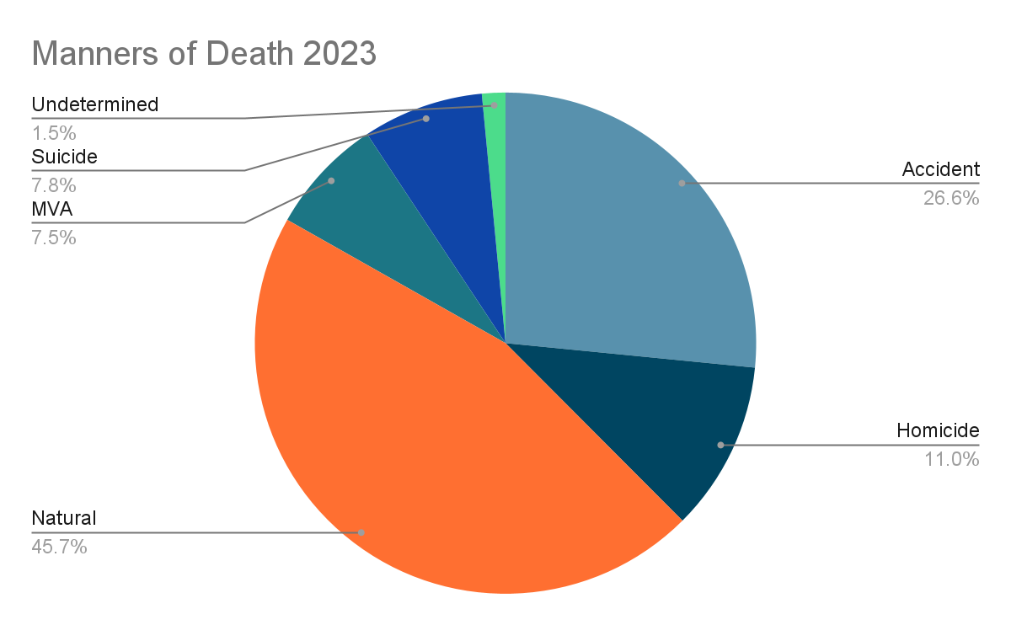

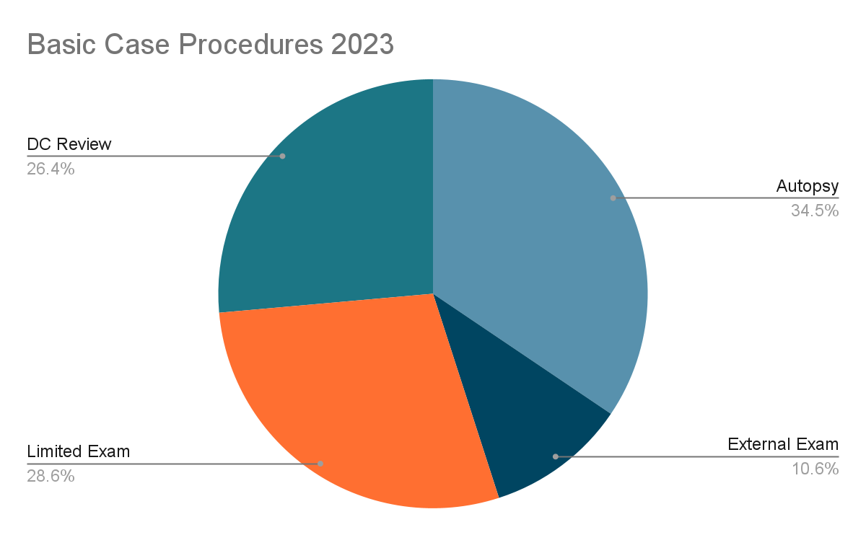

SECTION X: Special Topics

Deaths of Children Ages 1 through 17 years:

 | < = 10  Years Old | Cause | 11-17  Years Old | Cause
Accident | 9 | Airway Occlusion- External (1)  Asphyxia Compression(2)  Asphyxia Object(2)  Drowning (1)  Foreign Body Ingestion (1)  Gunshot Wound (1)  Hanging (1) | 3 | Drowning (2)  Overdose-Pharmaceutical (1)
Homicide | 7 | Drowning (1)  Injury- Blunt Force (1)  Malnutrition and Neglect (1)  GSW(2)  Overdose Illicit(2) | 12 | Gunshot Wound (12)
MV Accident | 2 | Pedestrian vs Motor Vehicle (2) | 4 | Motor Vehicle vs Motor Vehicle (4)
Natural | 3 | Infection- Pneumonia (1)  Infection- Gastroenteritis (1)  Respiratory- Congenital (1) | 4 | Status Asthmaticus (1)  Cardiac-Myocarditis (1)  Cerebral Palsy (2)
Suicide | 0 |  | 3 | Hanging (1)  Gunshot Wound (1)  Jump (1)
Undetermined | 10 | Sudden unexplained infant death(6)  Undetermined (4) | 1 | Fire (1)
Total |  |  |  | Total: 58

Childhood Deaths, Age Distribution and Manner of Death
Childhood Deaths, Age Distributions and manner of Death
Age in Months

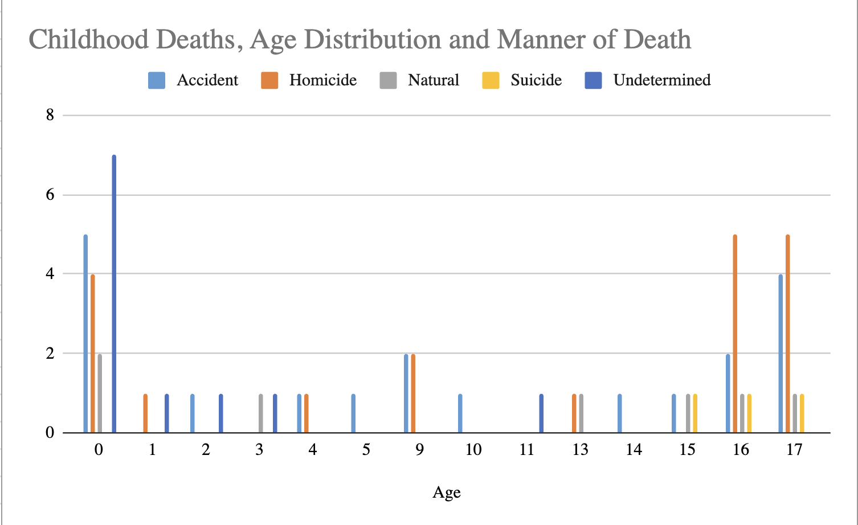
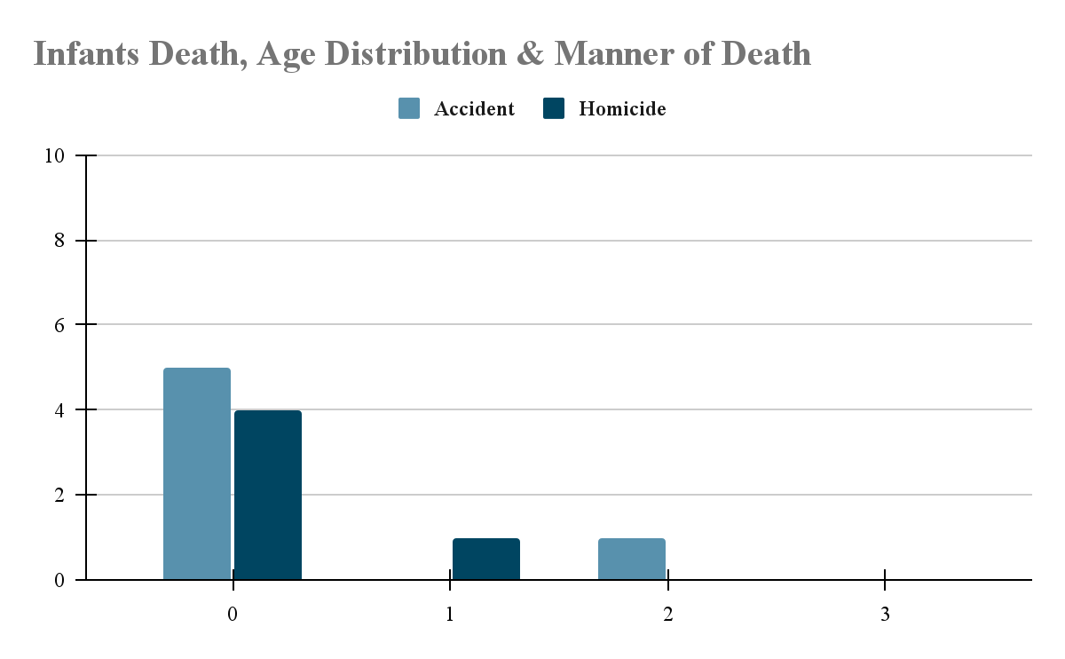
Age in years

Comments:

- Fulton County’s Georgia Child Fatality Review (CFR) Committee is chaired by the Fulton County District Attorney’s Office and conducts monthly reviews of decedents aged 17 and younger.

- The FCME participates in the committee by:
  - Hosting the monthly meeting.
  - Co-facilitating the meeting by presenting autopsy reports and photographs of decedents whose cases are reviewed by the panel.
  - Helping to enter decedent information into the on-line database of the National Center for Fatality Review and Prevention.

- The FCME also participates in the state of Georgia’s Child Fatality Review Panel which reviews county CFR cases.

Deaths among the Elderly:

Manner | Cause | 66-75 years old | 76-85 years old | 86-95 years old | 96 and over | TOTAL
ACCIDENT | Aircraft
ACCIDENT | Asphyxia-Food | 1 |  | 1 |  | 2
ACCIDENT | Asphyxia and Blunt Force trauma
ACCIDENT | Asphyxiation
ACCIDENT | Asphyxia-Positional
ACCIDENT | Airway Occlusion-Internal
ACCIDENT | Blunt Force Trauma and Illicit Drug Use | 1 |  |  |  | 1
ACCIDENT | Blunt Force Trauma and Natural Disease
ACCIDENT | Burn-Thermal
ACCIDENT | Drowning | 1 | 3 |  |  | 4
ACCIDENT | Drowning and Natural Disease |  | 1 |  |  | 1
ACCIDENT | Environmental hypothermia | 3 |  |  |  | 3
ACCIDENT | Drug Death | 21 | 1 |  |  | 22
ACCIDENT | Fall- Down Stairs | 2 |  | 1 |  | 3
ACCIDENT | Fall- From Height | 1 |  |  |  | 1
ACCIDENT | Fall-Ground Level | 19 | 25 | 21 | 2 | 67
ACCIDENT | Fall-To Floor |  |  | 2 |  | 2
ACCIDENT | Fire- Structure | 3 | 1 |  |  | 4
ACCIDENT | Hypothermia and Natural Disease | 1 |  |  |  | 1
ACCIDENT | Illicit Drug use and Cardiovascular Disease |  | 1 |  |  | 1
ACCIDENT | Injury- Blunt Force Trauma |  |  | 1 |  | 1
ACCIDENT (T) | Automobile vs. Automobile
ACCIDENT (T) | Automobile vs. Fixed Object
ACCIDENT (T) | Pedestrian vs Motor Vehicle | 7 | 3 |  |  | 10
ACCIDENT (T) | Pedestrian vs Train |  | 1 |  |  | 1
ACCIDENT (T) | Pedestrian vs Truck
ACCIDENT (T) | Automobile vs. Truck
ACCIDENT (T) | Motor Vehicle vs Fixed Object | 2 | 2 |  |  | 4
ACCIDENT (T) | Motor Vehicle vs Motor Vehicle | 3 | 1 | 3 |  | 7
ACCIDENT (T) | Motorcycle vs Motor Vehicle | 1 |  |  |  | 1
ACCIDENT (T) | Motor Vehicle Rollover | 1 |  |  |  | 1
NATURAL | Alzheimer Disease |  |  |  | 1 | 1
NATURAL | Bowel Obstruction |  | 1 |  |  | 1
NATURAL | Cancer- Bladder | 1 |  | 1 |  | 2
NATURAL | Cancer-Brain |  | 1 |  |  | 1
NATURAL | Cancer-Breast | 1 | 1 |  |  | 2
NATURAL | Cancer-Carcinoma (Metastic) |  | 1 |  |  | 1
NATURAL | Cancer- Cervical |  | 1 |  |  | 1
NATURAL | Cancer-Colon | 2 | 1 |  |  | 3
NATURAL | Cancer- Gastric | 1 |  |  |  | 1
NATURAL | Cancer-Head and Neck | 2 | 1 |  |  | 3
NATURAL | Cancer-Hematologic | 1 |  |  |  | 1
NATURAL | Cancer-Kidney | 1 | 1 |  |  | 2
NATURAL | Cancer-Liver | 1 |  |  |  | 1
NATURAL | Cancer-Lung | 5 | 1 |  |  | 6
NATURAL | Cancer-Prostate | 1 |  |  |  | 1
NATURAL | Cancer-Lymphoma | 1 |  |  |  | 1
NATURAL | Cancer-Multiple Myeloma | 1 |  |  |  | 1
NATURAL | Cardiac-Aortic Dissection | 1 | 1 |  |  | 2
NATURAL | Cardiac-Aortic Stenosis
NATURAL | Cardiac-Arrhythmia | 1 |  |  |  | 1
NATURAL | Cardiac - Arrhythmogenic right ventricular cardiomyopathy | 1 |  |  |  | 1
NATURAL | Cardiac-ASCVD | 11 | 6 | 2 |  | 19
NATURAL | Cardiac-ASCVD and Hypertension | 38 | 16 | 4 |  | 58
NATURAL | Cardiac- Cardiac Disease NOS
NATURAL | Cardiac – Coronary Artery Disease | 9 | 8 | 1 |  | 18
NATURAL | Cardiac-Congestive Heart Failure | 1 | 1 | 1 |  | 3
NATURAL | Cardiac-Hypertension | 84 | 38 | 24 | 3 | 149
NATURAL | Cardiac-Myocardial infarction |  | 1 |  |  | 1
NATURAL | Cardiac-NOS | 10 | 12 | 2 |  | 24
NATURAL | Cardiac-Coronary Artery Thrombosis | 2 |  |  |  | 2
NATURAL | Cardiac- Ruptured Aortic Aneurysm | 1 | 1 |  |  | 2
NATURAL | Cerebrovascular Disease
NATURAL | CNS-CVA (Stroke) | 1 |  | 1 |  | 2
NATURAL | CNS – Hemorrhage NOS |  | 1 |  |  | 1
NATURAL | CNS Hemorrhage- Hypertension | 1 |  |  |  | 1
NATURAL | CNS-Parkinson’s Disease
NATURAL | CNS Seizure Disorder |  | 1 |  |  | 1
NATURAL | CNS- Dementia | 1 |  | 1 |  | 2
NATURAL | Chronic Amyotrophic Lateral Sclerosis | 1 |  |  |  | 1
NATURAL | Chronic Kidney Disease | 2 |  |  |  | 2
NATURAL | Chronic Lung Disease | 1 |  |  |  | 1
NATURAL | Chronic Ethanol Abuse | 9 | 2 |  |  | 11
NATURAL | Diabetes Mellitus | 12 | 5 |  |  | 17
NATURAL | Drug Use Illicit
NATURAL | Environmental Hypothermia
NATURAL | Gastrointestinal Hemorrhage | 3 |  |  |  | 3
NATURAL | Infection-COVID-19 | 1 | 1 | 1 |  | 3
NATURAL | Infection- Cholangitis | 1 |  |  |  | 1
NATURAL | Infection-Diverticulitis | 1 |  |  |  | 1
NATURAL | Infection-Endocarditis |  | 1 |  |  | 1
NATURAL | Infection Pneumonia | 4 |  |  |  | 4
NATURAL | Infection-Sepsis | 1 | 1 |  |  | 2
NATURAL | Infection-UTI |  | 1 |  |  | 1
NATURAL | Nonspecific Natural Disease Process | 9 | 18 | 7 | 3 | 37
NATURAL | Organ Failure- Multiple Systems | 1 |  |  |  | 1
NATURAL | Pulmonary- COPD | 3 | 1 |  |  | 4
NATURAL | Pulmonary-Fibrosis | 1 |  |  |  | 1
NATURAL | Pulmonary- Embolism | 4 | 1 |  |  | 5
NATURAL | Pulmonary- Sarcoidosis | 1 |  |  |  | 1
NATURAL | Peripheral Vascular Disease | 1 |  |  |  | 1
NATURAL | Renal Failure | 1 |  |  |  | 1
NATURAL | Status Asthmaticus |  | 1 |  |  | 1
HOMICIDE | Blunt Force Trauma | 1 | 1 |  |  | 2
HOMICIDE | Fire | 1 |  | 1 |  | 2
HOMICIDE | Gunshot Wound(s) | 1 | 1 |  |  | 2
HOMICIDE | Homicidal Violence | 1 |  |  |  | 1
HOMICIDE | Injury-Blunt Force Trauma | 2 |  |  |  | 2
HOMICIDE | Use of Conducted Energy Device |  | 1 |  |  | 1
SUICIDE | Sharp Force Injury | 1 |  |  |  | 1
SUICIDE | Shotgun Wound | 2 |  |  |  | 2
SUICIDE | Drug Death | 2 | 1 |  |  | 3
SUICIDE | Gunshot Wound | 7 | 5 | 3 |  | 15
SUICIDE | Jump
SUICIDE | Vitiated Atmosphere |  |  |  |  | 1
UNDETERMINED | Overdose-Pharmaceutical | 1 |  | 1 |  | 1
TOTAL

Comments: Of the 2052 deaths certified by the medical examiner in 2023, 598 (29.1%) were persons 66 years of age or older.

Drugs Identified in 2023 FCME Death Investigations

Drug | Number of Cases
Acetyl fentanyl | 6
Acetaminophen | 1
Alcohol | 6
Alprazolam | 18
Amitriptyline | 1
Amphetamine | 95
Aripiprazole | 1
Buprenorphine | 1
Butyrylfentanyl | 1
Bromazolam | 10
Carisoprodol | 1
Chlorpheniramine | 1
Chlordiazepoxide | 2
Citalopram/Escitalopram | 1
Clonazepam | 10
Cocaine | 120
Codeine | 7
Cyclobenzaprine | 2
Dextromethorphan | 3
Diazepam | 3
Difluoroethane | 0
Diphenhydramine | 5
Duloxetine | 2
Ethanol | 47
Eutylone | 1
Ephedrine | 1
Fentanyl | 278
Fluoxetine | 1
Fluorofentanyl | 32
Flubromazepam | 1
Gabapentin | 3
Heroin | 17
Hydrocodone | 3
Hydromorphone | 2
Hydroxyzine | 3
Ketamine | 4
Methadone | 7
Methocarbamol | 1
Methamphetamine | 90
Mirtazapine | 2
Mitragynine | 12
Morphine | 16
Nordiazepam | 1
Oxycodone | 22
Promethazine | 1
Sertraline | 2
Tramadol | 2
Trazodone | 1
Topiramate | 1
Venlafaxine | 1
Xylazine | 20
Zolpidem | 2
3,4-Methylenedioxymethamphetamine | 1

Comments: The majority of drug deaths involve two or more substances. Drug deaths result not only from use of illicit substances, but from prescription and over-the-counter drugs as well.

Deaths among the Homeless:

Manner | Case Code | Race/Sex | <20 | 20-29 | 30-39 | 40-49 | 50-59 | 60-69 | 70-79 | 80-89 | Unk | Total
Natural | Cancer-Lung (1)  Cardiac-Coronary Artery Thrombosis (1)  Cardiac Hypertension(3)  Chronic Ethanol Abuse (1)  Chronic Lung Disease(1)  Diabetes Mellitus (1) | BM |  | 1 | 1 | 2 | 8 | 10 | 4 | 1
Natural | Infection-Pneumonia- Non Aspiration (1)  Infection-Urosepsis(1) | BF |  |  | 1 | 2
Natural |  | WF |  | 1
Natural |  | WM |  |  |  |  | 2 | 2
Natural |  | Other
Accident | Burns-Thermal(1) | BF | 0 | 0 | 0 | 3 | 2 | 1
Accident | Environmental Hyperthermia (1) | BM | 0 | 0 | 6 | 5 | 5 | 7
Accident | Environmental Hypothermia(3)  Overdose Alcohol(1)  Overdose Illicit (7)  Overdose Mixed (4) | WM | 0 | 0 | 5 | 3 | 8 | 0
Accident |  | WF | 0 | 1 | 1 | 9 | 2 | 1
Accident(T) | Pedestrian vs MV (1)  Pedestrian vs Train (1) | BF
Accident(T) | Pedestrian vs MV (1)  Pedestrian vs Train (1) | BM
Accident(T) | Pedestrian vs MV (1)  Pedestrian vs Train (1) | WM
Homicide | Blunt Force Trauma (1) | BF
Homicide | Blunt Force Trauma (1) | BM |  |  |  | 1 | 1 | 1
Homicide |  | BF
Homicide | Gunshot Wound (3) | WF
Homicide |  | WM |  |  |  |  | 1
Suicide | Hanging (1)  Gunshot Wounds (2) | BF |  | 1
Suicide | Hanging (1)  Gunshot Wounds (2) | WF
Suicide | Hanging (1)  Gunshot Wounds (2) | WM |  |  |  | 1
 |  | BM |  |  | 1
TOTAL |  |  | 0 | 4 | 15 | 26 | 29 | 22 | 4 | 1

Comparison with the past: Manners of Death 2000-2023
Year | Homicides | Suicides | Traffic Fatalities | Other Accidents
2000 | 172 | 76 | 143 | 192
2001 | 171 | 87 | 125 | 265
2002 | 203 | 83 | 125 | 265
2003 | 181 | 79 | 113 | 276
2004 | 159 | 90 | 137 | 240
2005 | 145 | 78 | 130 | 262
2006 | 149 | 77 | 132 | 245
2007 | 182 | 86 | 121 | 275
2008 | 156 | 84 | 119 | 255
2009 | 129 | 86 | 111 | 233
2010 | 146 | 101 | 80 | 266
2011 | 126 | 98 | 76 | 239
2012 | 135 | 102 | 89 | 234
2013 | 141 | 119 | 102 | 268
2014 | 154 | 106 | 101 | 332
2015 | 157 | 115 | 105 | 337
2016 | 193 | 120 | 137 | 378
2017 | 134 | 127 | 119 | 318
2018 | 157 | 132 | 132 | 356
2019 | 183 | 129 | 138 | 340
2020 | 258 | 107 | 170 | 382
2021 | 259 | 155 | 185 | 539
2022 | 278 | 138 | 186 | 533
2023 | 225 | 160 | 154 | 545

Comparison with the past: Examinations performed 2000-2023
Year | Total Cases | Certified | Autopsies | External Exams | On-Scene Investigation | Total Bodies Examined*
2000 | 2098 | 1349 | 784 | 331 | 832 | 1331
2001 | 2014 | 1361 | 831 | 355 | 885 | 1406
2002 | 2063 | 1326 | 843 | 302 | 930 | 1322
2003 | 2298 | 1312 | 860 | 412 | 960 | 1554
2004 | 2254 | 1324 | 874 | 310 | 883 | 1312
2005 | 2171 | 1322 | 887 | 369 | 896 | 1427
2006 | 2212 | 1401 | 921 | 436 | 890 | 1495
2007 | 2238 | 1403 | 1002 | 365 | 921 | 1482
2008 | 2271 | 1386 | 940 | 303 | 894 | 1420
2009 | 2371 | 1418 | 893 | 456 | 856 | 1441
2010 | 2477 | 1416 | 910 | 367 | 848 | 1414
2011 | 2337 | 1299 | 868 | 338 | 780 | 1321
2012 | 2241 | 1315 | 832 | 391 | 825 | 1313
2013 | 2429 | 1454 | 952 | 442 | 1032 | 1511
2014 | 2594 | 1583 | 1027 | 525 | 1084 | 1635
2015 | 2545 | 1596 | 1052 | 483 | 995 | 1622
2016 | 2730 | 1693 | 1098 | 521 | 1113 | 1723
2017 | 2524 | 1370 | 757 | 565 | 1149 | 1621
2018 | 2551 | 1346 | 876 | 413 | 1248 | 1679
2019 | 2422 | 1354 | 882 | 402 | 1100 | 1494
2020 | 2665 | 1636 | 989 | 647 | 888 | 2,548
2021 | 3086 | 2090 | 1250 | 674 | 1553 | 2,262
2022 | 2943 | 2168 | 993 | 394 | 1750 | 2182
2023 | 2921 | 1572 | 1293 | 217 | 1540 | 2052

*Indicates cases in which the body was examined by an investigator and/or medical examiner.
Comments:
The services provided by the Fulton County Medical Examiner go beyond the routine duties of conducting death investigations. Some of these other services include:
- Testifying in court cases.
- Participating in county and state Child Fatality Review Teams and preparing child fatality information for the Child Death Review reporting system.
- Giving lectures and training sessions.
- Providing a forensic pathology training program.
- Providing death investigations and forensic technician internships.
- Reporting notifiable conditions to the Health Department.
- Reporting applicable deaths to federal agencies such as the Consumer Product Safety Commission and the Food and Drug Administration.
- Reporting childhood deaths to the Child Fatality Review Team and District Attorney.
- Reporting traffic fatalities to the Fulton County Solicitor.
- Reporting homicide victims to the Fulton County District Attorney.
- Participating in national organizations such as the National Association of Medical Examiners and their activities.
- Development and maintenance of in-house databases.
- Reporting unidentified decedents to NCIC (National Crime Information Center) and the NamUs Unidentified Decedent Reporting System.
- Providing forensic pathology and death investigation experience to undergraduate students interested in forensic science/medicine and to paramedic/EMT firefighter students, medical students, and nursing students at Morehouse School of Medicine, Emory University School of Medicine, and other medical institutions.

